

**Semester One Examination 2016**

**Question/Answer Booklet**

**PHYSICS**

**UNIT 1**

**Name:__________________________________________**

**Time allowed for this paper**:

Reading time before commencing work: 10 minutes

Working time for paper: Two and a half(2.5) hours

**Materials required/recommended for this paper**

***To be provides by the supervisor***

This Question/Answer Booklet

Formulae and Data Booklet

***To be provided by the candidate***

Standard items: pens, pencils (including coloured), sharpener, correction fluid, eraser, ruler, highlighters.

Special items: up to three non-programmable calculators approved for use in the WACE examinations, drawing templates, drawing compass and a protractor.

***IMPORTANT NOTE TO CANDIDATES***

No other items may be taken into the examination room. It is **your** responsibility to ensure that you do not have any unauthorised notes or other items of a non-personal nature in the examination room. If you have any unauthorised material with you, hand it to the supervisor **before** reading any further.

**STRUCTURE OF THIS PAPER**

|  |  |  |  |  |  |  |
| --- | --- | --- | --- | --- | --- | --- |
| Section | No. of  Questions | No. of questions  to be attempted | Suggested working time  (minutes) | | Marks available | Percentage of  exam |
| 1: Short response | 11 | ALL | 40 | | 44 | 30 |
| 2: Problem-solving | 6 | ALL | 70 | | 70 | 45 |
| 3: Comprehension | 2 | ALL | 40 | | 36 | 25 |
| Total | **150** | **100** |

**INSTRUCTIONS TO CANDIDATES**

Write your answers in the spaces provided beneath each question. The value of each question (out of 150) is shown following each question.

The enclosed Physics: Formulae and Constants Sheet may be removed from the booklet and used as required.

Calculators satisfying conditions set by the School Curriculum and Standards Authority may be used to evaluate numerical answers. The calculator **cannot** be a “**graphics”** calculator.

Answers to questions involving calculations should be evaluated and given in decimal form. Final answers should be given up to three significant figures and include appropriate units where appropriate. Despite an incorrect final result, credit may be obtained for method and working providing these are clearly and legibly set out.

Questions containing specific instructions to **show working** should be answered with a complete, logical, clear sequence of reasoning showing how the final answer was arrived at; correct answers which do not show working will not be awarded full marks.

Questions containing the instruction "**ESTIMATE**" may give insufficient numerical data for their solution. Show your working or reasoning clearly. Give final answers to a maximum of two significant figures and include appropriate units where applicable.

Spare pages are included at the end of this booklet. They can be used for planning your responses and/or as additional space if required to continue an answer.

* + Planning: If you use the spare pages for planning, indicate this clearly.
  + Continuing an answer: If you need to use the space to continue an answer, indicate in the original answer space where the answer is continued, i.e. give the page number. Refer to the question(s) where you are continuing your work.

**Section One: Short response 30% (44 marks)**

This section has 11 questions. Answer **all** questions. Answer the questions in the spaces provided.

Suggested working time: 40 minutes.

**Question 1 (4 marks)**

(a) List two assumptions of the kinetic particle model. (2 marks)

(b) Dry ovens cook food by circulating hot air around it. Steam ovens cook food by circulating steam. If both types of oven are set to 100 °C, a carrot cooks in a few minutes in a steam oven, but takes hours to cook in a dry oven. Suggest a reason why. (2 marks)

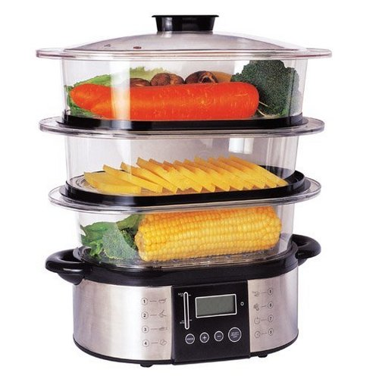

**Question 2 (4 marks)**

(a) Explain why heat transfer by conduction is more effective in liquids than in gases. (2 marks)

(b) Explain why aluminium is a better conductor of heat than phosphorus, despite the fact that both are solids at room temperature and they have similar atomic masses.

(2 marks)

**Question 3 (4 marks)**

(a) Recent advances have increased the efficiency of some petrol engines to 35%. Explain what happens to the other 65% of the energy.

(2 marks)

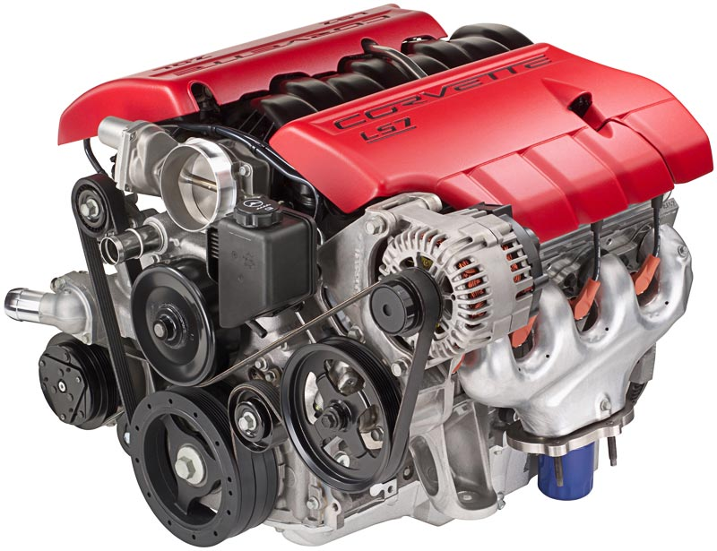

(b) Describe two ways that a car engine can be cooled.

(2 marks)

**Question 4 (4 marks)**

Below is a graph showing the distribution of kinetic energy of particles for two different samples of zinc that are at two different temperatures.

Number of Particles

Kinetic Energy

Sample A

Sample B

(a) Which of the two samples of zinc would have the higher temperature? Explain your choice.

(2 marks)

(b) Which is likely to have greater internal energy – an indoor swimming pool that has been heated to 28 °C or a stainless steel paper clip heated to 1,100 °C? Explain your answer.

(2 marks)

**Question 5 (4 marks)**

State whether each of the following statements is true or false:

(a) The nucleons in an atom are held together due to the attraction between positively charged protons and negatively charged electrons.

True / False (1 mark)

(b) Nuclear fusion reactions release more energy than fission reactions in total, however fission reactions release more energy per nucleon.

True / False (1 mark)

(c) Alpha particles have a relatively poor penetrating power, but they have a relatively high ionising ability.

True / False (1 mark)

(d) Alpha, beta and gamma radiation will be deflected near a charged plate.

True / False (1 mark)

**Question 6 (4 marks)**

The activity of an unknown radioactive source was measured for a period of 5 minutes and 50.0 seconds. At the end of this time, its activity was measured to be 15.0 Bq. If the half-life of the material is 70.0 s, calculate its activity at the start of the measurement period (i.e., when t = 0 s)?

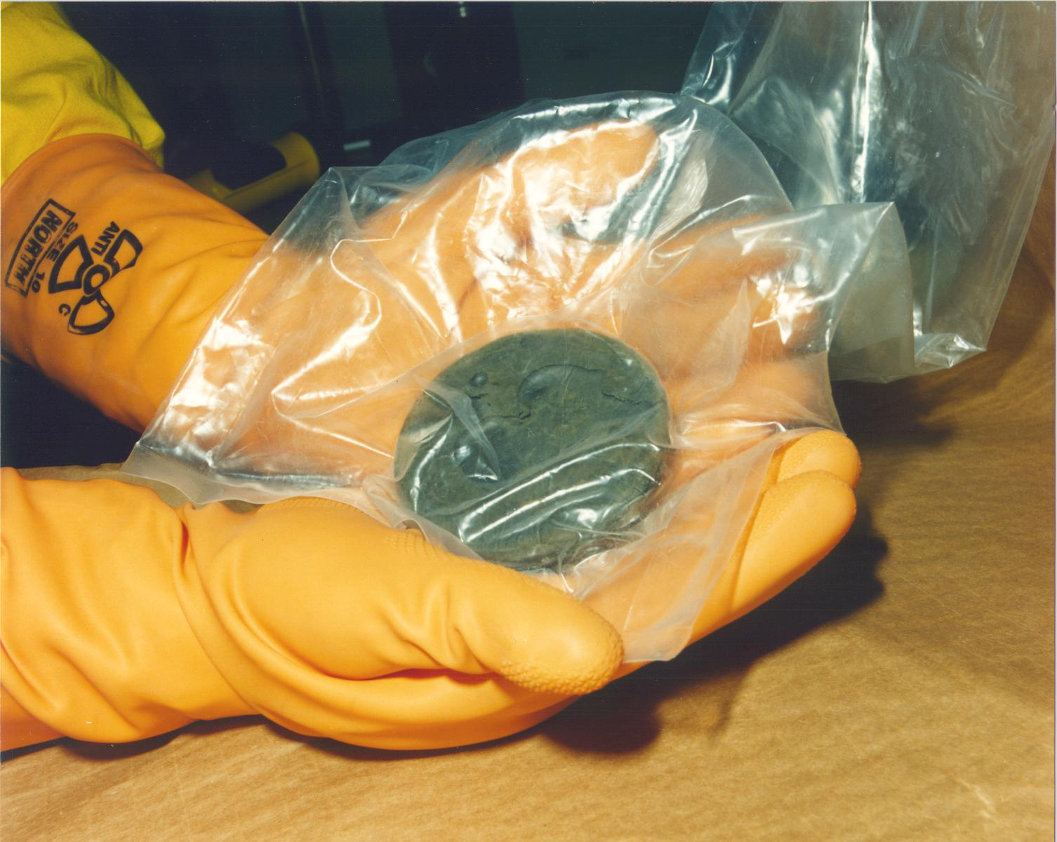

**Question 7 (4 marks)**

Complete the following sentences by inserting either: alpha radiation, beta radiation, or gamma radiation:

(a) ________________ is the least ionising type of radiation (1 mark)

(b) The radiation that comprises particles of the greatest charge is ______________ (1 mark)

(c) ________________ has the highest penetrating power (1 mark)

(d) The radiation that has the lowest emission velocity is ________________ (1 mark)

**Question 8 (4 marks)**

A 65.0 kg technician accidentally ingested a source of alpha radiation. Over the next 4.00 hours she absorbed 3.18 J of energy before removing the radioactive materials from her body by vomiting.

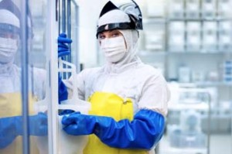(a) Calculate the technician’s absorbed dose over the four-hour period (1 mark)

(b) Calculate the technician’s dose equivalent over the four-hour period. (1 mark)

(c) Should the technician be concerned about her radiation exposure? (2 mark)

**Question 9 (4 marks)**

Draw an arrow on each of the following diagrams to indicate the direction in which a net force would be exerted on object A. If you decide that no net force is present, explain your answer.

(a) A negatively charged plate is close to object A, which is also negatively charged. (1 mark)

**-**

**-**

**-**

**-**

**-**

**-**

Object A

(b) A positively charged sphere is close to object A, which is negatively charged. (1 mark)

**+**

**-**

Object A

(c) Positively charged object A is between two plates with *equal* negative charges. (1 mark)

**+**

Object A

**-**

**-**

**-**

**-**

**-**

**-**

**-**

**-**

**-**

**-**

(d) Two positively charged spheres are in the same horizontal plane. Point A, which is negatively charged, is directly above one of the spheres. (1 mark)

**+**

**-**

Object A

**+**

**Question 10 (4 marks)**

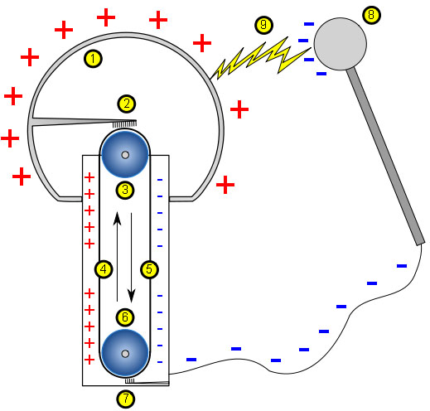In a Van de Graaff generator a rubber belt rubs against an acrylic plate transferring electrons from the plate to the belt. Calculate the electric current generated when 2.70 x 1018 electrons are transferred to the rubber belt over a period of 5 minutes and 30.0 seconds.

**Question 11 (4 marks)**

Capacitors store electrical energy by keeping opposite charges separated on parallel metal plates. An insulator between the plates maintains the charge separation.

(a) Briefly explain why charge separation would result in energy being stored. (2 marks)

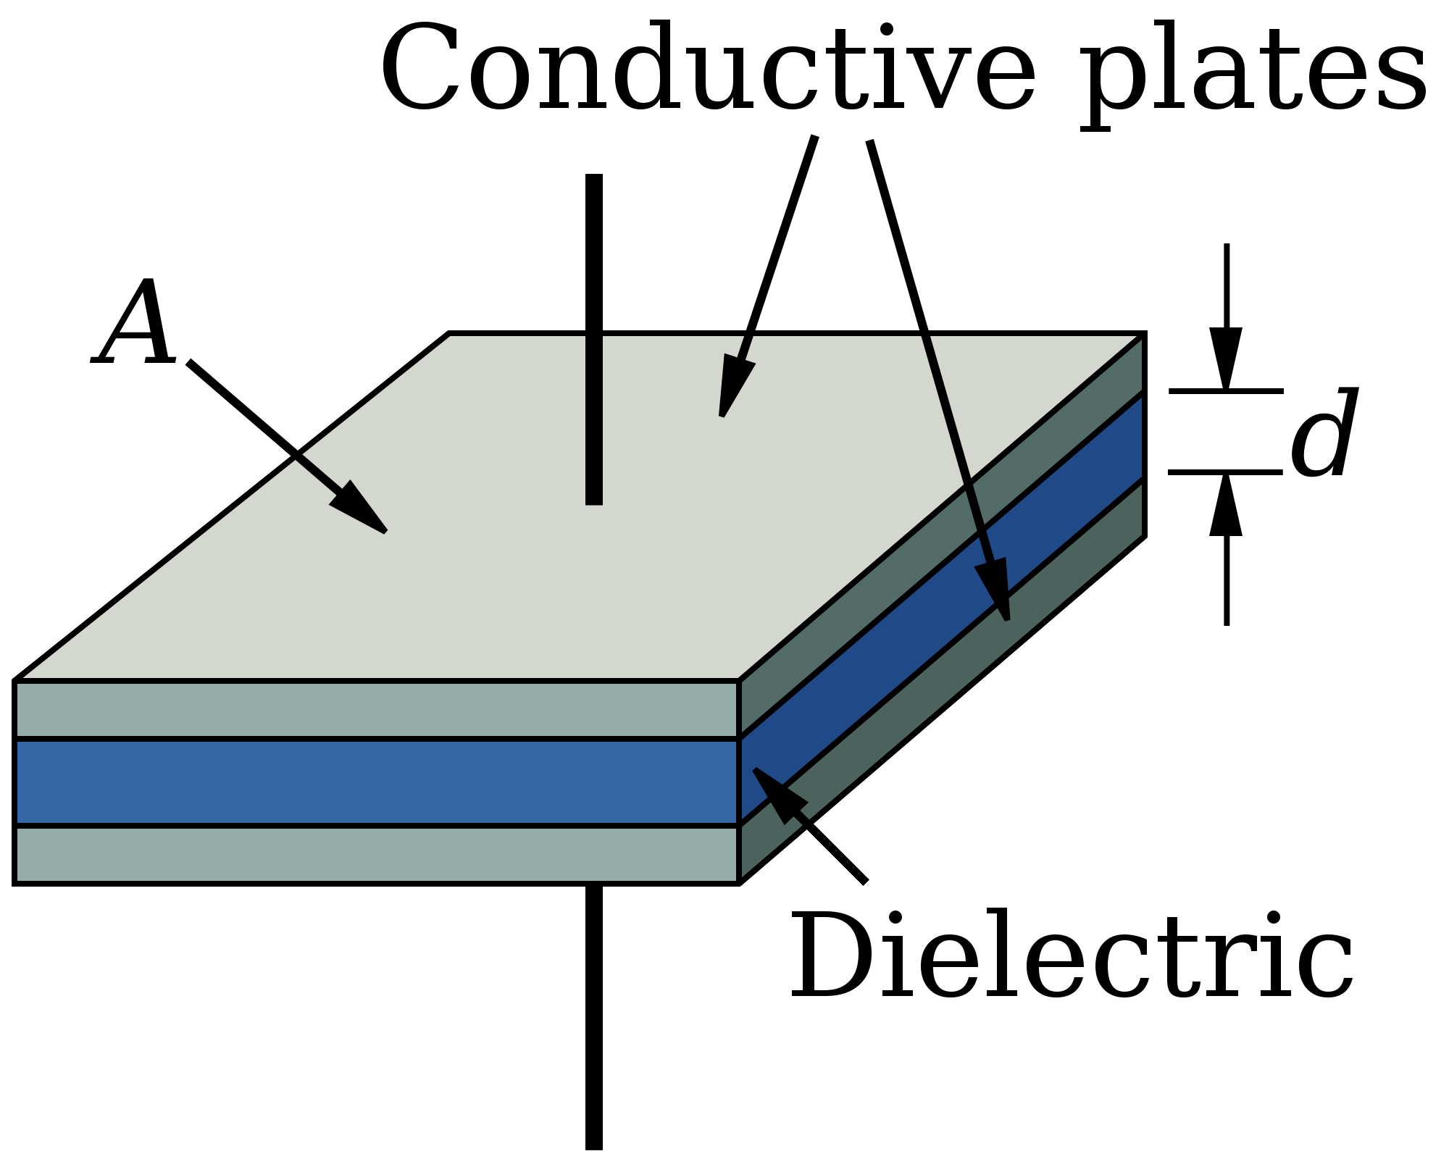

(b) A battery has some similarities with a capacitor in that there is a separation of charges. The charge separation is achieved by a chemical reaction. If the chemical reaction does 4.50 J of work for each 3.13 x 1018 electrons, what is the voltage of the battery? (2 marks)

**END OF SECTION ONE**

**Section Two: Problem-solving 45% (70 marks)**

This section contains 6 questions. Answer **all** questions. Answer the questions in the spaces provided.

Suggested working time 70 minutes.

**Question 12 (13 marks)**

A beaker holding 45.5g of ice is heated from a temperature of -30.4 °C until it melts completely at

0.00 °C. Heat continues to be applied until the resulting liquid begins to boil at 1.00 x 102 °C.

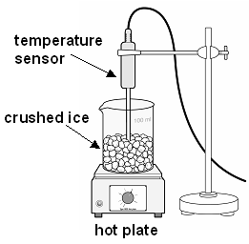

(a) Calculate the amount of energy required to heat the beaker of ice from -30.4 °C until it just starts to melt. (2 marks)

(b) Calculate the amount of energy required to melt the ice. (2 marks)

(c) Calculate the amount of energy required to heat the liquid from 0.00 °C to 1.00 x 102 °C.

(2 marks)

(d) Once the liquid had reached its boiling point, calculate the amount of energy required to boil it all off. (2 marks)

(e) A hotplate supplied all of the heat in this example. Briefly describe how you could estimate the power output of the hotplate, indicating any additional measurements that may be required to make this estimation. (2 marks)

(f) If it was determined that the hotplate had a power output of 1.24 kW, calculate the amount of time taken for the solid ice (which was initially at -30.4 °C) to be completely boiled off using this hotplate. (3 marks)

**Question 13 (13 marks)**

A Styrofoam cup has a mass of 48.7 g. After water was added, the combined mass of the cup and the water was 167.3 g. The water had an initial temperature of 25.5 °C. A 23.2 g mass of a metal was heated to a temperature of 99.0 °C and added to the water in the cup. The water and the metal reached thermal equilibrium at a temperature of 26.8 °C.

(a) Calculate the specific heat of the metal. (5 marks)

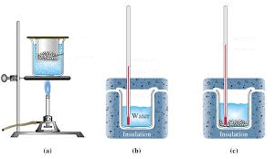

(b) After the metal and water had reached thermal equilibrium, the metal was removed from the water and the metal and the water were both heated separately such that they each received an additional 555 J of heat energy. Assuming no heat energy is lost to the environment, just as the metal is placed back in the water, will the metal and the water still be in thermal equilibrium? Explain your answer by including a calculation (if you did not determine the specific heat of the metal in part (a), use a value of 4.00 x 102 J kg-1 K-1). (4 marks)

(c) If the Styrofoam cup was not a perfect insulator, how would this affect the determination of the specific heat capacity of the metal (assuming the temperature of the room was lower than that of any of the materials being used)? Explain your answer. (4 marks)

**Question 14 (11 marks)**

Many homes use solar energy to heat water. One design uses solar collectors to directly heat water by the sun. The heated water is then stored for later use. There are two main components to these types of solar hot water systems:

* A solar collector, through which water passes and absorbs thermal energy from the sun. The water typically runs through copper tubes, which transfer the sun’s energy; and
* A storage tank that stores hot water from the solar collector.

(a) In one design, the storage tank is located above the solar collector. Water circulates from the collector to the storage tank without the use of a pump. Explain how this happens.

(3 marks)

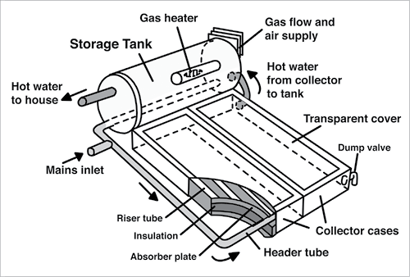

(b) Calculate the internal energy of the water in the system if, over a period of an hour, the sun adds an amount of energy equal to 3.65 MJ to the water, but the system loses 1.40 MJ of its energy to the surroundings. (2 marks)

(c) Calculate the efficiency of the energy storage system from part (b). (2 marks)

(d) If the hot water system holds 3.00 x 102 L of water, calculate the increase in temperature of the water in one hour if the system absorbs 3.45 kW of solar energy (assuming all efficiency losses have been taken into account).

(4 marks)

**Question 15 (13 marks)**

Thorium-based nuclear power plants take advantage of the fission of uranium-233, which is produced from thorium decay. The thorium fuel cycle can be represented using the following equations:

(a) What type of decay does the thorium-233 undergo to form protactinium-233? (1 mark)

(b) What type of decay does the protactinium-233 undergo to form uranium-233? (1 mark)

When used as a fuel, a uranium-233 nucleus can absorb a neutron to form an unstable uranium-234 nucleus, which later decays into zirconium and tellurium:

The masses for the above nuclei, along with a more precise mass for a neutron, are shown below:

mass of a neutron = 1.674929445 x 10-27 kg

mass of U-233 = 3.869716824 x 10-25 kg

mass of Zr-93 = 1.542749382 x 10-25 kg

mass of Te-138 = 2.290370146 x 10-25 kg

(c) Calculate the amount of energy in eV released in the above nuclear reaction.

(5 marks)

Although there are no existing commercial thorium-based reactors, they may prove to be safer than present reactors by enabling greater control over the rate of fission and reducing the chance of nuclear meltdown.

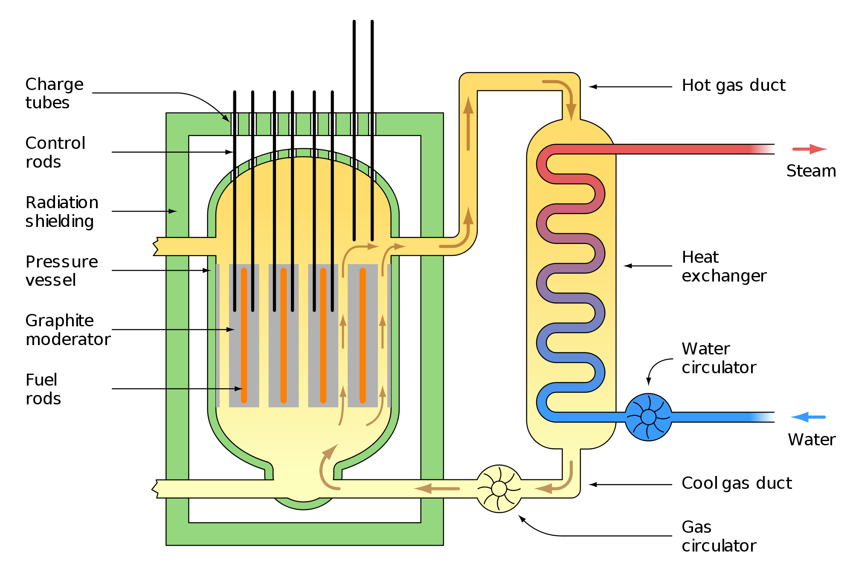

Two features of current nuclear reactors that allow us to control nuclear reaction rates are the *moderator* and the *control rods*.

(d) Briefly describe the function of:

(i) the moderator (2 marks)

(ii) the control rods (2 marks)

(ii) the radiation shielding (2 marks)

**Question 16 (11 marks)**

The first nuclear weapon used in warfare was the ‘Little Boy’ atomic bomb, which was dropped on the Japanese city of Hiroshima on 6 August 1945 during World War II.

The bomb had an estimated blast yield that was equivalent to 15.0 kilotons of TNT being detonated.

(a) Given that one ton of TNT is equivalent to about 4.18 GJ of energy, calculate the mass of fissile material that would have been converted into energy in the explosion. (3 marks)

The Little Boy atomic bomb contained 64.1 kg of enriched uranium-235.

(b) Calculate the percentage of the mass of the Little Boy’s fissile material that was converted into energy (2 marks)

The Little Boy atomic bomb was a ‘gun-type’ fission weapon. When the bomb was detonated, a 38.5 kg ‘bullet’ of uranium-235 was fired towards a 25.6 kg ‘target’ of uranium-235. The combined uranium-235 then began nuclear fission and energy equivalent to 15.0 kT of TNT was released.

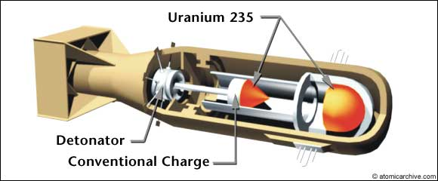

(c) Suggest why the atomic bomb didn’t undergo a fission reaction prior to the ‘bullet’ of U-235 combining with the ‘target’ of U-235. (3 marks)

(d) Today’s most powerful nuclear weapons use a fission reaction to start a fusion reaction. Suggest reasons why nuclear weapons that use a fusion reaction are more powerful than those that only use fission reactions. (3 marks)

**Question 17 (9 marks)**

A resistor is connected to a 12.0 V battery via conductive wires as shown in the following circuit diagram.

12 V

1.2 kΩ

The resistor has a value of 1.20 kΩ.

(a) Draw a voltmeter and ammeter on the circuit diagram to show how they would be connected to measure the current and voltage in the circuit. (2 marks)

(b) Calculate the current flowing through the 1.20 kΩ resistor. (1 mark)

(c) Calculate the power that is consumed by the 1.20 kΩ resistor. (2 marks)

In the above calculations we have ignored any resistance that the electrical conductors may have.

(d) If the resistance of the electrical conductors was high enough that it had an effect on the circuit, would more or less power be consumed by the 1.20 kΩ resistor? (1 mark)

(e) If the electrical conductors were all made of the same conductive material, what would be the effect of the following changes on the overall resistance of the circuit?

(i) longer wires were used (1 mark)

(ii) thicker wires were used (1 mark)

(iii) the temperature of the wires was increased (1 mark)

**END OF SECTION TWO**

**Section Three: Comprehension 25% (36 marks)**

This section has two questions. Answer **both** questions. Answer the questions in the spaces provided.

Suggested working time: 40 minutes.

**Question 18 (15 marks)**

**Star Fuel**

Two features of a star can be used for classification purposes: its colour and its brightness. By plotting each star’s colour against its brightness, they tend to form distinct groups. One of these groups is called the ‘main sequence’ which corresponds to stars that generate thermal energy by the nuclear fusion of hydrogen atoms into helium. The Sun is an example of a star that is in the main sequence.

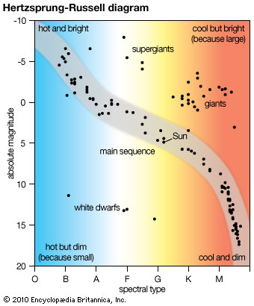

The main sequence is typically divided into two parts – upper and lower. Stars that are less than about one and a half times the mass of the Sun are classed in the lower part of the main sequence. Stars in this part generate thermal energy primarily by the fusion of hydrogen atoms into helium in a process known as the proton-proton chain reaction. Stars that have a mass greater than this are classed in the upper part of the main sequence in which hydrogen fusion occurs as part of a set of reactions known as the CNO cycle.

The proton-proton chain reaction involves a number of reactions that occur in sequence. The first of the reactions involves two hydrogen atoms fusing to form a diproton:

Diprotons are very unstable and can either decay back into two protons, or undergo beta decay to produce deuterium, a positron and an electron neutrino (), as shown in the following reaction:

The deuterium can then undergo fusion with a further proton to produce helium-3:

After helium-3 has been produced a number of different reactions can occur to produce helium-4. The main type of fusion reaction that results in the formation of helium-4 is called the ‘pp I’ branch reaction in which two helium-3 nuclei can fuse to form helium-4 and hydrogen.

The pp I branch reaction can be represented as follows:

The CNO cycle starts at higher temperatures than the proton-proton chain reaction, and involves four hydrogen nuclei fusing to form helium-4, two positrons and two electron neutrinos. The manner in which the hydrogen nuclei fuse can vary, but typically involve carbon, nitrogen and oxygen atoms acting as catalysts.

Stars in the main sequence rely on a core of hydrogen to provide the fuel for the fusion processes. After a star’s hydrogen has been consumed, it will evolve into a white dwarf directly if its mass is less than about 0.3 times the mass of the Sun, or indirectly by way of first becoming a red giant if its mass is between about 0.3 to 10 times that of the Sun. If the star is super-massive, it may become a supergiant, with the potential of exploding as a supernova.

Regarding the future of our Sun, it is estimated that there was initially enough hydrogen in its core that it would take in the order of ten billion years to be consumed. Over this time, 3.6 x 1038 protons are being converted into helium every second, releasing energy at a rate of 3.86 x 1026 W. It is about half way through its life as a stable star and is estimated to remain stable for about the next four billion years. The Sun is not massive enough to end its life as a supernova – it will instead become a red giant in about 5.4 billion years.

(a) What does the abbreviation CNO stand for? (1 mark)

(b) What is a diproton? (1 mark)

(c) What is deuterium? (1 mark)

(d) What feature of stars in the upper main sequence facilitates the CNO cycle being the dominant energy production mechanism? (1 marks)

(e) Determine the amount of energy released in the pp I branch reaction given the following information: (4 marks)

mass of a proton = 1.67262178 x 10-27 kg

mass of a helium-3 nucleus = 5.008237929 x 10-27 kg

mass of a helium-4 nucleus = 6.646483608 x 10-27 kg

(f) Write a reaction equation for the fusion of the four protons to form helium-4. (3 marks)

(g) Consider the following statement: “A star that has a mass that is 6.7 times that of the sun will not become a white dwarf, and will instead become a red giant”. Is this statement true or false? Justify your answer. (1 marks)

(h) Given that the total number of protons that fuse to form helium over the life of the Sun represents 10% of the mass of the Sun, provide an estimate for the total mass of the Sun. (3 marks)

**Question 19 (21 marks)**

**Conductance**

The ‘specific conductance’ of a material provides an indication as to its ability to conduct electricity. Specific conductance is represented by the symbol σ, and is measured in siemens per metre (S m-1). The conductance of a material will increase as the material’s cross-sectional area increases, and decrease with the length of the material. This leads to the general expression:

where:

G is the electrical conductance of the material (S);

A is cross-sectional area of the material (m2);

l is length of the material (m); and

σ is the specific conductance of the material (S m-1).

Electrical conductance, G, can also be defined by its relationship to current and voltage. In particular, electrical conductance is defined as:

where:

I is the current flowing through the material (A); and

V is the voltage across the material (V).

The specific conductance of some materials is shown in the table below:

|  |  |
| --- | --- |
| **Material** | **Specific Conductance (S m-1)** |
| Carbon (graphene) | 1.00 x 108 |
| Copper | 5.96 x 107 |
| Aluminium | 3.50 x 107 |
| Platinum | 9.43 x 106 |
| Lead | 4.55 x 106 |

An experiment was conducted to determine the specific conductance of a particular type of metal. The metal was formed into a series of wires that all had the same length, but different diameters. Each of the metal wires was connected to a DC voltage source, and both the current flowing through and the voltage drop across the material was measured to determine the electrical conductance of the material. A 100 Ω resistor was connected in series with the metal wire to reduce the maximum current flowing through the circuit. The following results were obtained as a result of the experiment:

|  |  |  |  |  |  |
| --- | --- | --- | --- | --- | --- |
| Length of the metal wire (m) | Diameter of the metal wire (mm) | Area of the metal wire (m2) | Voltage drop across the metal wire (V) | Current flowing through the metal wire (A) | Conductance  (S) |
| 0.100 | 0.100 | 0.785 x 10-8 | 0.260 | 1.175 |  |
| 0.100 | 0.150 | 1.77 x 10-8 | 0.120 | 1.189 |  |
| 0.100 | 0.200 |  | 0.0640 | 1.194 |  |
| 0.100 | 0.250 | 4.91 x 10-8 | 0.0420 | 1.196 |  |
| 0.100 | 0.300 |  | 0.0284 | 1.198 |  |

(a) Complete the table by filling out the values for electrical conductance of the wire, and the missing values for the cross-sectional area (some of the values for the area have been filled in for you).

(3 marks)

(b) State the independent variable in the above experiment (1 mark)

(c) State the dependent variable in the above experiment. (1 mark)

(d) State two controlled variables in the above experiment. (2 marks)

(e) Draw a circuit diagram to show how these results were obtained. Include the ammeter and voltmeter and other circuit elements described in the experimental set-up.

(2 marks)

(f) Plot a graph of electrical conductance against the cross-sectional area of the wire. (4 marks)

prac exam youngs mod 10 by 10

(g) Determine the gradient of the graph. (3 marks)

(h) Hence calculate the specific conductance of the material (3 marks)

(i) Use the table of specific conductances to identify the material (2 marks)

**END OF SECTION THREE**

**END OF EXAM**

Extra Working Space (Number question carefully)

Spare Graph Paper

prac exam youngs mod 10 by 10